SRM ARTS AND SCIENCE COLLEGE-KATTANKULATHUR

DEPARTMENT OF ELECTRONICS AND COMMUNICATION SCIENCE

**Illuminating insight from Uber expanditonary analysis**

**TEAM MEMBERS**

1. DANDU ARUN KUMAR
2. DHANUSH.K
3. DHANUSH.S
4. RAGHUL.N
5. MOHAMED HUSSAIN.M

**TABLE OF CONTENT**

**1.INTRODUCTION**

1.1 OVERVIEW

Uber is a multinational transportation network company that operates a ride-hailing platform. It was founded in 2009 by Garrett Camp and Travis Kalanick and is based in San Francisco, California. Uber provides a convenient way for individuals to request rides from drivers who use their own personal vehicles.

1.2 PURPOSE

Our purpose is to analyze the trend of the crop production and productivity in various region of India.

**2.PROBLEM DEFINITION & DESEIGN THINKING**

2.1 EMPATHY MAP

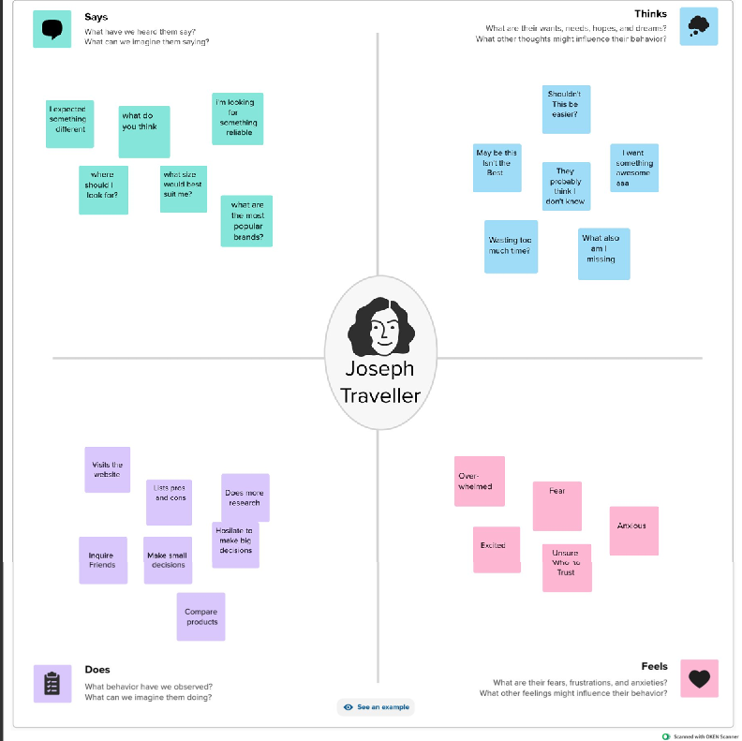

2.1 BRAINSTROMING MAP

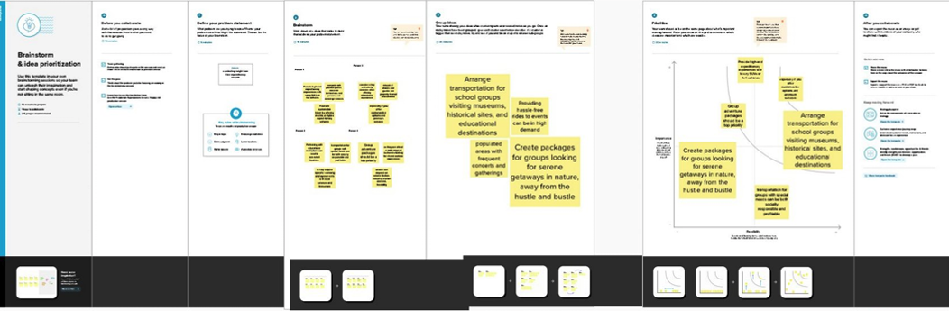

**3.RESULT**

* In various markets often hinged on its ability to adapt to local cultures, regulations, and preferences. This flexibility allowed Uber to gain a foothold in regions where it faced strong competition or regulatory hurdles.
* A data analytics and technology to optimize operations and pricing has been a key factor in its expansion success.
* Finally, understanding the competitive landscape and how Uber has positioned itself within each market provides valuable insights into the company's expansion strategy.
* In summary, insights from Uber's expansionary analysis results highlight the importance of localization, data analytics, partnerships, diversification, and competitive strategies as key elements of its global expansion success.

**C:\Users\Admin\Pictures\Screenshots\Screenshot 2023-10-13 153236.png**

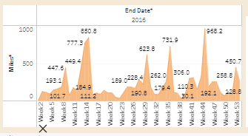

**NUMBER OF TRIPS PER MONTH**

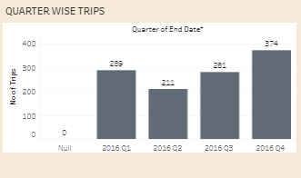

**QUARTER WISE TRIPS**

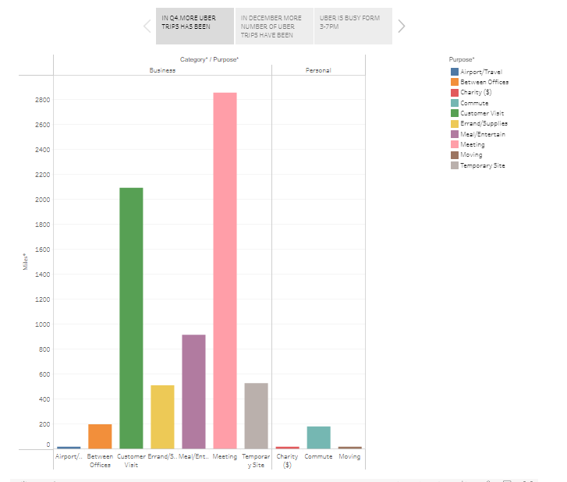

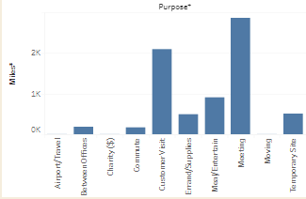

**MONTH WISE MILES**

**4.ADVANTAGES AND DISADVANTAGES**

**ADVANTAGES:**

* Market Penetration: Uber expanded rapidly into various markets, gaining a strong global presence. This helped them reach a broad customer base and gain a competitive edge.
* Diversification: Expansion allowed Uber to diversify its services beyond ride-sharing, including UberEats and Uber Freight, reducing risk associated with a single service.
* Network Effects: As Uber expanded, its network effects grew stronger. More drivers and riders attracted even more users, creating a virtuous cycle.

**DISADVANTAGES:**

* Expanding into new regions often meant navigating complex and varying regulations. This resulted in legal battles and operational setbacks.
* Uber faced strong competition in many markets, often resulting in price wars and substantial marketing expenses to gain market shares

* Adapting to local cultures and preferences was sometimes challenging and could lead to missteps.

**5.APPLICATIONS**

Uber's expansion results reflect a complex blend of global success, innovation, economic impacts, regulatory challenges, and societal changes. It highlights the transformative power of tech-driven transportation companies and the need for adaptability in the face of various challenges.

**6.CONCLUSION**

This adaptability has allowed Uber to gain a competitive edge in many markets, even when faced with established local competitors. Additionally, the data-driven approach of Uber, using analytics and real-time information, has been instrumental in optimizing its operations and pricing strategies, enhancing user experiences, and managing supply and demand efficiently.

**7.FUTURE SCOPE**

This suggests that Uber's future expansion may involve exploring new verticals and services, such as healthcare transportation, autonomous vehicles, and more. In summary, the future scope of Uber's expansionary analysis should focus on diversification, regulatory challenges, sustainability efforts, and technological advancements as key drivers of its expansion strategies.